[](http://connect/DirectoratesandTeams/Communications/Brand/Shared%20Documents/Brand/Brand%20guidelines/Logo%20new%20strap%20CMYK-02.jpg)

Partnerships Executive – Corporate and Philanthropy

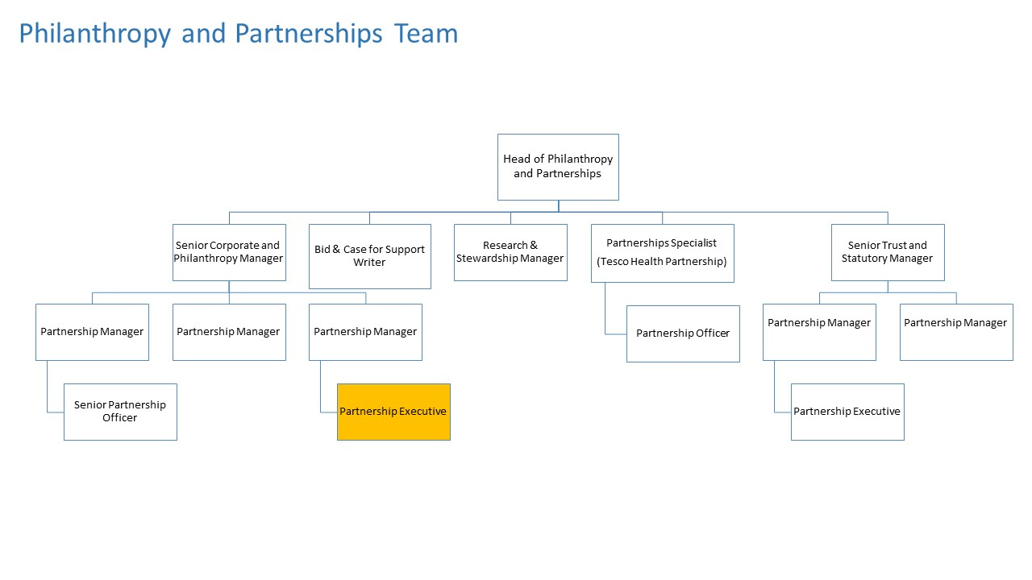

|  |  |
| --- | --- |
| DIRECTORATE: | Engagement and Fundraising |
| SECTION: | Philanthropy and Partnerships |
| REPORTING TO: | Philanthropy Manager |
| CONTRACT: | Permanent |

**WORKING RELATIONSHIPS**

|  |
| --- |
| **Inside Diabetes UK** |
| Philanthropy and Partnerships team, wider Engagement and Fundraising Directorate, key delivery teams across the organisation, Finance team, Data team, Legal, IT, Digital, Business support, Research team |
| **Outside Diabetes UK** |
| Key senior volunteers, current and potential major donors, current and potential corporate partners, current and potential trust, statutory or institutional funders, peers in the sector, agencies and consultants as required |

# OVERALL PURPOSE OF THE JOB

The purpose of this role is to support the team in securing and managing high value relationships and/or partnerships with current and potential corporate supporters or individual donors. The role will also involve managing individual donor relationships, projects and events to contribute to the team targets. The post holder will create engaging materials, write donor development and stewardship plans, as well as offering event support (including acting as lead on some events) and will ensure donor records and pipelines are up to date. They will support the team to work in a joined up way.

**MAIN DUTIES AND RESPONSIBILITIES**

* To support the team in securing and managing high value corporate and major donor relationships in line with the team’s strategic plan and pipeline
* To take on the management of donor/supporter relationships, projects and events, including securing new corporate and individual relationships where appropriate
* Account manage and develop a small portfolio of corporate partners and individual major donors in line with either individual or team targets
* To provide donor recognition and donor stewardship support
* To work across the whole Philanthropy and Partnerships team, ensuring we deliver a joined up approach to all major funding opportunities
* To provide an excellent donor experience whilst ensuring donor records are up to date and maintained
* To contribute to the team income target, and to work to individual targets as directed

**TEAM SUPPORT**

* To support the day-to-day activities of the team, as directed by the Partnership Manager and Senior Partnerships Manager
* To lead on or provide support for donor events e.g. lab tours, fundraising dinners etc.
* Working with the Research and Stewardship Manager to ensure maximum use is made of the database and that pipeline and other documents are kept up to date
* To create proposals, newsletters, bespoke donor recognition and other key materials
* To provide support for internal and external meetings with donors/supporters and/or senior staff and volunteers

**RELATIONSHIP MANAGEMENT**

* To support Partnership Managers with relationship management where appropriate and ensure an excellent supporter experience
* To take on the management of donor/supporter relationships, projects and events, including securing new corporate and individual relationships where appropriate
* Account manage and develop a small portfolio of corporate partners and individual major donors in line with either individual or team targets
* To ensure that we are seen as an appealing partner to work with
* To build strong internal and external relationships as needed to support the effective delivery of the team’s activities
* To lead on the contracting process with corporate supporters
* To create or support the creation of clear donor development plans
* To work with the team to secure new corporate and individual relationships, taking the lead on this as appropriate

**PLANNING AND REPORTING**

* To deliver KPI reporting as required
* To contribute to planning and budget setting for the team
* To maintain up to date and comprehensive donor records
* To ensure all activity is conducted in line with the fundraising Code of Practice and all other legal and regulatory requirements
* Agree income and expenditure targets as agreed and set in conjunction with the Senior Manager/Partnerships Managers and prepare monthly financial commentary reports

**OTHER**

* To represent Diabetes UK as required
* Any other duties commensurate with the role that may reasonably be required
* To provide direction to volunteers as needed

**PERSON SPECIFICATION:**

|  |
| --- |
| **The best person for this job will be able to:** |
| * Demonstrate experience in being outcome and delivery focused * Demonstrate an attention to detail and commitment to getting it right * Learn and develop in a sector-leading partnerships team |

|  |
| --- |
| **The best person for this job will have experience in:** |
| * Managing relationships * Database usage * Providing excellent administrative support   **It would be desirable to have experience in the following:**   * Event planning or project management * Meeting support/minute-taking * Prospect or supporter research * Corporate and/or Philanthropy fundraising |

|  |
| --- |
| **The best person for this job will be:** |
| * Someone with excellent communication skills * Someone with strong relationship-building skills * Able to manage a complex workload, and prioritise * Keen to learn and develop   **It would be desirable if the person was:**   * Educated to degree level, however candidates with relevant work experience will be considered for this post. |

**Other information:**Due to the nature of fundraising, there will be occasional evening and weekend work as well as travel to Diabetes UK national and regional offices.