[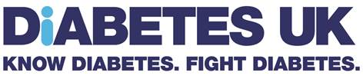](http://connect/DirectoratesandTeams/Communications/Brand/Shared%20Documents/Brand/Brand%20guidelines/Logo%20new%20strap%20CMYK-02.jpg)

Job Title Content Producer

|  |  |
| --- | --- |
| DIRECTORATE: | Engagement and Fundraising |
| SECTION: | Content |
| REPORTING TO: | Content Manager (with dotted line to Type 1 diabetes programme lead) |
| CONTRACT: | Fixed-term contract until end of June 2019 |

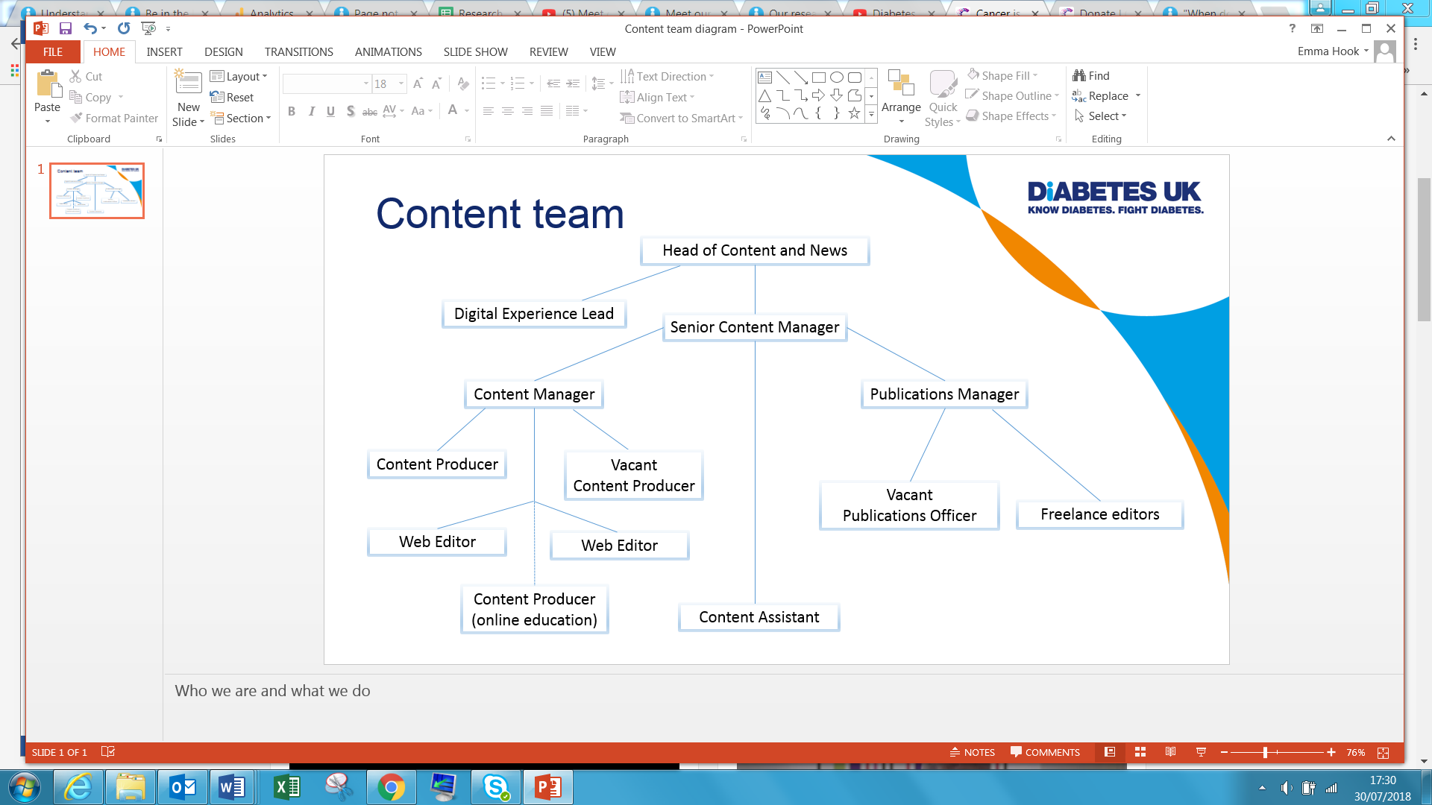

WORKING RELATIONSHIPS:

|  |
| --- |
| **Inside Diabetes UK** |
| Type 1 team, Brand and Creative, Video Producer, Digital, Clinical, Strategic Marketing, Press team. |
| **Outside Diabetes UK** |
| People with Type 1 diabetes (and their family and friends), schools professionals, digital and content production companies, content agencies, copywriters, editors, photographers, videographers, PR agencies and health-related charities. |

# OVERALL PURPOSE OF THE JOB

The Content team is dedicated to strengthening and maintaining our position as the trusted source of information for anyone living with, affected by and at risk of diabetes. Our remit is to produce audience-first, insight-driven, responsive, relevant and engaging content. The team acts as an internal content agency, which is responsible for the ownership, development and publishing (online and offline) of Diabetes UK patient information, educational content and magazine and lifestyle content. Achieving a revolution in understanding and support is a major strategic priority for the charity, and content plays a major role in this. The ideas and expertise of the content team will result in high-profile content that drives awareness, engagement and conversion through our online and offline channels.

This Content Producer role will work across two main teams – reporting to the Content Manager but with a dotted line into the Type 1 programme lead (in the Type 1 diabetes team). You will work closely with the Type 1 team to ensure content is integrated with the Type 1 team’s marketing and communications activity.

Type 1 diabetes is a serious, lifelong condition where your blood glucose level is too high because your body can't make a hormone called insulin. Around 10% of people living with diabetes in the UK have Type 1 diabetes. It’s the most common type of diabetes in childhood but it can develop at any age. We don’t know exactly what causes Type 1 diabetes. But we do know it’s not caused by your lifestyle – it’s an autoimmune condition. Type 1 diabetes is complicated, so our content needs to be easy-to-understand, engaging and relevant.

Your focus will be to maintain, produce and commission audience-first, digital content across our website and social media channels for people living with Type 1 diabetes.

This will mainly involve planning, sourcing, editing, producing and project managing high-quality, creative and engaging digital content and online resources (and occasionally offline). This role will harness the power of great storytelling with great writing and ensure we put the audience at the forefront of all our content.

You will edit current web content for SEO and usability, write new and engaging copy, work with our Video Producer to brief and project manage video production, commission photography and brief designers on graphics. You will ensure that all content created is reflective of our brand essence, and always embodies our tone of voice characteristics: authentic, inspiring, frank, confident and human, working closely with our Clinical team to ensure clinical accuracy.

Sitting within the Content team, but with close links to the Type 1 project team, your role will focus on content for people with Type 1 diabetes, but you’ll work closely with colleagues across the department to optimise the potential of content to reach broader audiences and help support Diabetes UK’s wider vision to create a world where diabetes can do no harm.

**MAIN DUTIES AND RESPONSIBILITIES:**

* Conceive, develop and commission new Type 1 diabetes content as well as update and improve existing content for our website and other multimedia channels, in line with web best practice, priority areas of work and organisational strategic objectives.
* Plan, research, project manage, write, produce, edit, sub and proof content across a range of outputs, including but not limited to online and offline information resources.
* Work closely with the Type 1 Marketing and Communications Manager to deliver Type 1 specific campaigns to budget and to deadline.
* Use SEO, keyword research and analytics to ensure best performance of content and ensure there are regular review check points in place.
* Work to continually improve webpage navigation, performance and readability.
* Support the Content Manager to build a culture of content that is co-produced by people with diabetes and their families, and user-generated content is captured and embedded wherever possible and appropriate.
* Produce responsive content to be reactive to live situations and scenarios.
* Create clear briefs for creative assets needed to support content production. Work closely with the Creative team to explain and share photography and videography requirements.
* Manage agencies and external providers to deliver content and digital products. This includes full project management, from brief to delivery, including writing briefs, reviewing responses, managing internal stakeholder requirements and approvals, ensuring the delivery of content on time and within agreed budgets.
* Provide content support to other areas of the organisation and contribute to creative ideas generation, as and when required.
* Keep up-to-date on the latest content, digital and publishing developments.
* Work with the wider Marcomms teams to explore opportunities to extend Type 1 content to reach wider audiences where relevant, for example those living with or at risk of Type 2.

**PERSON SPECIFICATION:**

|  |
| --- |
| **The best person for this job will be able to:** |
| * Have extensive practical knowledge of working with a content management system (CMS) or any other web authoring package, ideally Drupal 8 CMS. * Excellent copywriting, editing and proofreading skills demonstrating good editorial judgement particularly for the web, digital platforms and enewsletters. * Excellent understanding of Search Engine Optimisation, Google Analytics and other analytical tools. * Knowledge of industry best-practices, including content delivery standards, accessible digital content and usability of websites. * Exceptional organisational and project management skills. * Work as a part of a team as well as independently. * Excellent verbal communications skills and the ability to work with and influence staff at all levels in an organisation. * Apply user-led insight to content creation processes in order to meet customer needs and achieve organisation goals. * Adept at using Microsoft Office programs including Outlook, Word, Excel, PowerPoint, and Adobe Suite including Photoshop. * Have an enviable portfolio showing a proven track record of developing creative solutions and engaging content. |

|  |
| --- |
| **The best person for this job will have experience in:** |
| * At least two years' relevant work experience in digital content planning and production. * Experience of project managing projects from concept to delivery. * Experience of writing, editing and creating engaging and impactful audience-focused content. * Experience of monitoring and evaluating content activity, and making improvements based on learnings. * Experience of setting and working to busy schedules, working under pressure in a fast-paced environment and to tight deadlines. * Experience of working with content agencies to develop audio visual content, writing clear and accurate briefs when commissioning content. * Experience of Drupal 8 CMS. * Experience of creating social media and digital marketing content. |

|  |
| --- |
| **The best person for this job will be:** |
| * An excellent editor and writer, with a meticulous attention to detail. * Driven to succeed – a completer-finisher. * Able to hit the ground running, learning to navigate a complex organisation and its policies and procedures. * A people person, good at building relationships. * An experienced project manager. * Passionate about making a difference to the lives of families living with Type 1, so that they have the information and support they need, and helping to improve their long-term health outcomes. * Charity/NFP sector experience. * Editorial/journalism experience. * Ability to identify and overcome problems using own initiative. |